C. Program PL/SQL # 4C: Edit PL/SQL program using Oracle character functions to display  
the hospital name, virus name and number of hospitalisations of a given entered hospital  
information as shown hereafter.  
Requirements: The entered hospital info of character data type includes the following rules:  
• Hospital name as three sub strings separated by one space such as: Jewish General  
Hospital or Royal Victoria Hospital.  
• Number of hospitalisations separated by one space from Hospital name such as  
406 Jewish General Hospital

My code in assignment

1. *--C. Program PL/SQL # 4C: Edit PL/SQL program using Oracle character functions*
2. *--to display the hospital name, virus name and number of hospitalisations of*
3. *--a given entered hospital information as shown hereafter.*
4. declare
5. hospitalInfo        VARCHAR2(40);
6. numberHospital      Number(3);
7. blank_space         Number(3);
8. nameHospital        VARCHAR2(30);
9. today_date          date;
10. begin
11. hospitalInfo := '&hospitalInfo';
12. *--    hospitalInfo := '406 Jewish General Hospital';*
13. blank_space := instr(hospitalInfo, ' ');
14. numberHospital := substr(hospitalInfo, 0, blank_space);
15. nameHospital := substr(hospitalInfo, blank_space+1,
16. length(hospitalInfo) - blank_space);
17. today_date := sysdate;
18. dbms_output.put_line('Today''s date With a given Format is ' ||
19. to_char(today_date,'DY, MONTH DD, YYYY HH24:MI:SS A.M.'));
20. dbms_output.put_line('Original hospitalInfo is : ' || hospitalInfo);
21. dbms_output.put_line('Number of hospitalisations is : '
22. || numberHospital);
23. dbms_output.put_line('Hospital Name is : '
24. || nameHospital);
25. end;

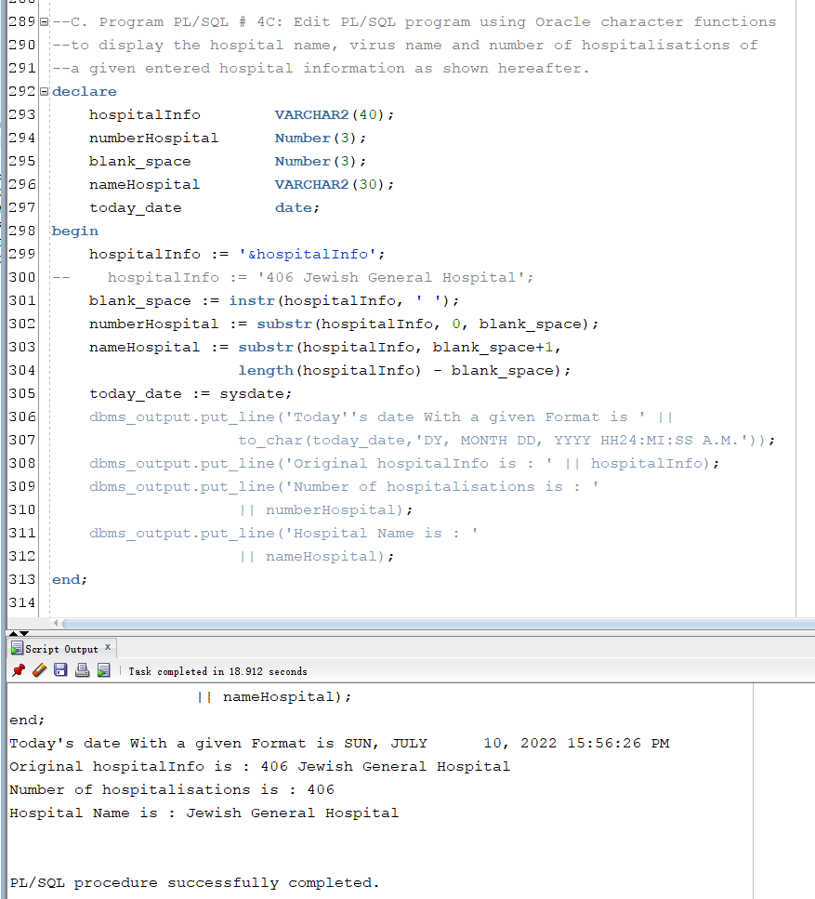

D. Program PL/SQL # 4D: Taking into account the previous requirements, edit PL/SQL  
program using Oracle character functions (SUBSTR, and INSTR to locate the occurrence of  
multiple blank spaces) in order to display the number of hospitalisations, cause of  
hospitalisation, wave number, and hospital name of a given entered hospital info such as:  
406 COVID19Delta 4 Jewish General Hospitalwhich stands for  
406 as number of hospitalisations  
COVID19Delta as cause of hospitalisation (here virus COVID19 Delta variant)  
4 as wave number 4  
Jewish General Hospital as hospital name

My code in assignment

1. declare
2. hospitalInfo        VARCHAR2(80);
3. numberHospital      Number(3);
4. causeHospital       VARCHAR2(15);
5. waveNumber          Number(2);
6. nameHospital        VARCHAR2(30);
7. today_date          date;
8. blank_space1        Number(3);
9. blank_space2        Number(3);
10. blank_space3        Number(3);
11. begin
12. hospitalInfo := '&hospitalInfo';
13. *--    hospitalInfo := '406 COVID19Delta 4 Jewish General Hospital';*
14. blank_space1 := instr(hospitalInfo, ' ', 1, 1);
15. blank_space2 := instr(hospitalInfo, ' ', 1, 2);
16. blank_space3 := instr(hospitalInfo, ' ', 1, 3);
17. numberHospital := substr(hospitalInfo, 0, blank_space1);
18. causeHospital := substr(hospitalInfo, blank_space1+1, blank_space2-blank_space1);
19. waveNumber := substr(hospitalInfo, blank_space2+1, blank_space3-blank_space2);
20. nameHospital := substr(hospitalInfo, blank_space3+1,
21. length(hospitalInfo) - blank_space3);
22. today_date := sysdate;
23. dbms_output.put_line('Today''s date With a given Format is ' ||
24. to_char(today_date,'DY, MONTH DD, YYYY HH24:MI:SS A.M.'));
25. dbms_output.put_line('Original hospitalInfo is : ' || hospitalInfo);
26. dbms_output.put_line('Number of hospitalisations is : '
27. || numberHospital);
28. dbms_output.put_line('Cause of hospitalisations is : '
29. || causeHospital);
30. dbms_output.put_line('Wave number is : '
31. || waveNumber);
32. dbms_output.put_line('Hospital Name is : '
33. || nameHospital);
34. end;

